**NLP ASSIGNMENT**

**Objective**: This project aimed to perform a word analysis on news reports related to the Hamas-Israel conflict from five major news agencies.

**Select News Agencies**: Five major news agencies—CNN, NBC News, NY Times, Telegraph, and Washington Post.

**Data Scraping :** Use web scraping techniques to gather text data from the chosen news agencies over the course of one month.

**Preprocessing the Data:** Clean and preprocess the collected data. Handling special characters, remove some words like say and said and tokenizing the text into words.

**Natural Language Processing (NLP) Analysis:**

**Sentiment Analysis:**

**Determine the overall sentiment of each news article to understand the emotional tone.**

**Sentiment Analysis Results:**

**CNN:** 0.019660 (Positive Sentiment): CNN's sentiment score is positive, suggesting that the overall tone of its reporting on the Hamas-Israel conflict tends to be optimistic or favorable.

**NBC News:** 0.022790 (Positive Sentiment): NBC News also received a positive sentiment score, indicating that their reporting on the conflict is generally positive or optimistic in nature.

**NY Times:** 0.020496 (Positive Sentiment): The New York Times (NYT) scored positively as well, suggesting that their coverage of the conflict leans towards a positive or optimistic perspective.

**Telegraph:** 0.008226 (Slightly Positive Sentiment): The Telegraph received a positive sentiment score, though slightly lower than the others. This suggests a generally positive tone, but with less intensity compared to CNN, NBC News, and NY Times.

**Washington Post:** -0.012399 (Negative Sentiment): The Washington Post has a negative sentiment score, indicating that their reporting on the conflict tends to have a critical or pessimistic tone.

**Topic Modeling:**

**Topic 1:** Keywords: attack, israel, hamas, war, killed.

**Interpretation:** This topic seems to focus on violent incidents, including attacks, casualties, and the involvement of both Israel and Hamas in the conflict.

**Topic 2:** Keywords: gaza, israel, war, israeli, palestinian.

**Interpretation:** This topic revolves around the geographical locations of Gaza and Israel, highlighting their roles in the conflict. The terms suggest discussions on war and the involvement of Israeli and Palestinian entities.

**Topic 3:** Keywords: gaza, israeli, israel, minister, conflict.

**Interpretation:** This topic touches upon political aspects, including discussions related to ministers, conflicts, and the role of Israel in the conflict.

**Topic 4:** Keywords: said, israel, palestinian, agency, attack.

**Interpretation:** This topic appears to involve statements ("said"), discussions on Palestinians, agencies, and further mentions of attacks. It may cover a range of perspectives and reports.

**Topic 5:** Keywords: gaza, israel, israeli, hamas, attack.

**Interpretation:** This topic seems to focus on the ongoing conflict in Gaza and Israel, involving terms like attacks, the military, and official statements from various entities.

**Word Cloud Analysis:**

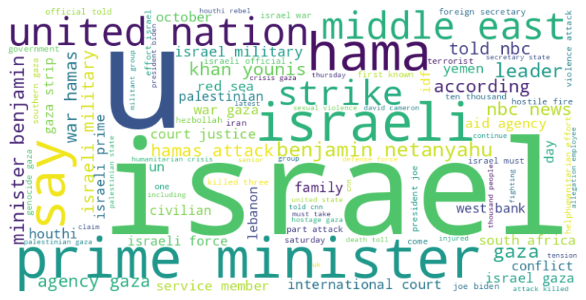

**Top Ten Words Used in Headings:**

israel: 571,gaza: 462 said: 342,attack: 326,israeli: 316,hamas: 255,war: 243,palestinian: 202,military: 183,u: 151